18 Sep update — SUMO pipeline and first M1 results
Jaeyun Ree · 18 September 2026 · for discussion with Eunus (Aamir optional). Follows the 7 Sep report on the exact optimum.

1. What we did
- Built the SUMO pipeline end to end on a real corridor: M1 Monash Freeway inbound, Springvale Rd → CityLink, 20.5 km, 31 road segments, 16 ramps (8 on, 8 off).
- Wrote a converter that turns SUMO output into the paper's vehicle format, so greedy and ILA run on it unchanged.
- Measured how the real corridor differs from the uniform synthetic data used in the paper.
- Ran greedy and ILA on the M1 instance over AV:PV ratios 0.2–0.8 (Eunus's question on the ratio).
- Surveyed Victorian open traffic-count data (DTP) to see whether demand can be calibrated to real counts.

2. How
OpenStreetMap → netconvert → randomTrips (placeholder demand, 1 hour, 1800 vehicles) → sumo → converter → greedy / ILA.
- Positions are projected onto the paper's 0–100 grid: 1 unit = 205 m, so L_min = 10 units ≈ 2 km.
- Each vehicle's speed and entry time are fitted from its simulated trajectory (constant-speed fit, as the model assumes).
- AV / PV labels are assigned at random (20 % AV for the smoke run; varied for the ratio sweep). SUMO has no such concept; the rule is ours to decide.
- Time tolerance τ = 5 model time units, as in the paper. One model time unit on the M1 is about 8 s (see §4).
Caveat. Demand is a randomTrips placeholder: only the road network is real. Where vehicles enter and exit, and how long they stay, is shaped by the real ramps; how many take each route is still uniform. Structure numbers below hold regardless; saving percentages do not.
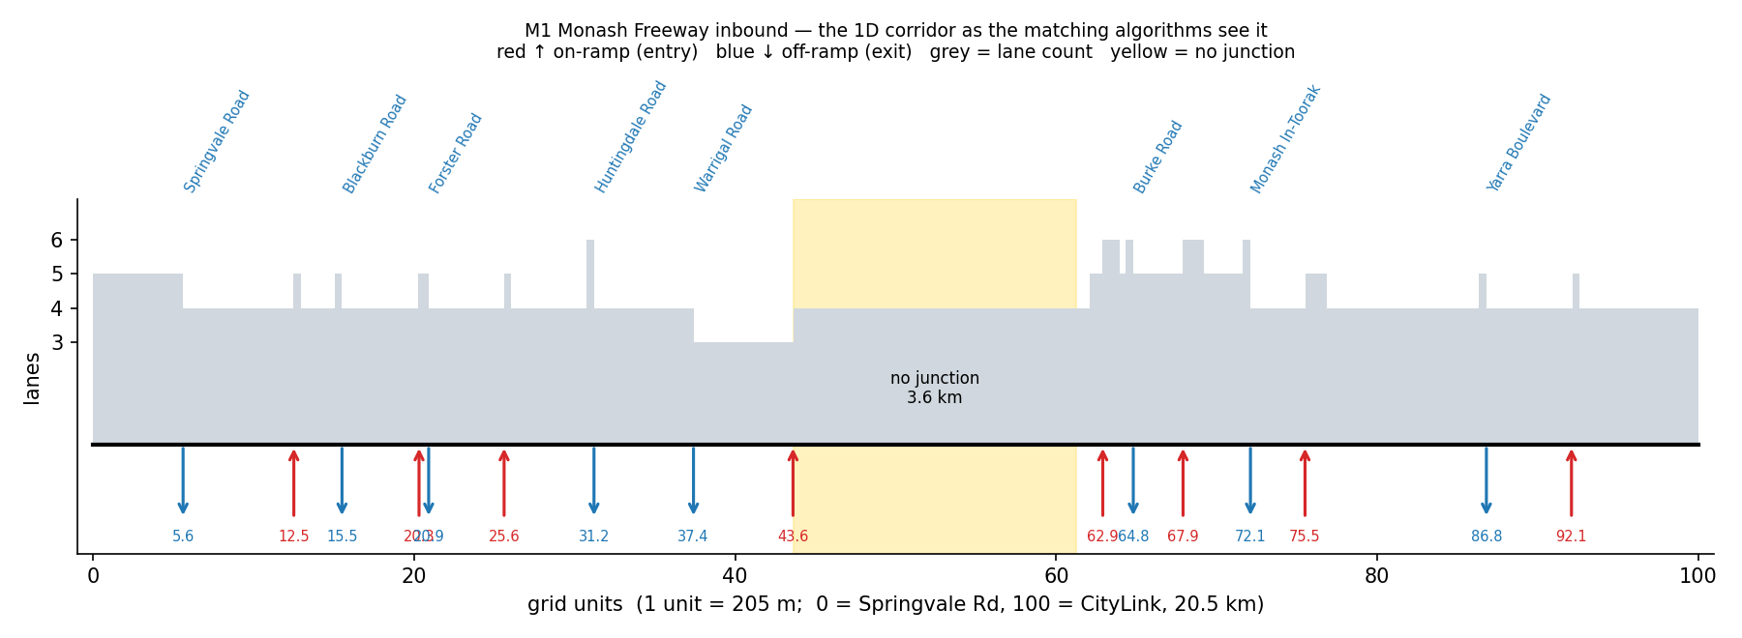
Figure 1. The M1 inbound corridor as the algorithms see it: 16 ramps on the 100-unit grid, lane count, and a 3.6 km stretch with no junction.

3. Results

3.1 What the real corridor changes (independent of the demand model)
 | Synthetic (paper) | M1 inbound
Possible entry points | 101 (uniform) | 9 (corridor start + 8 on-ramps)
Possible exit points | 101 (uniform) | 9 (8 off-ramps + corridor end)
Origin–destination pairs that occur | thousands | 44
Trips shorter than L_min (≈ 2 km) | 0 by design | 18 % (adjacent ramps are 0.6 km apart in places)
Speeds | 0.8–1.2 (arbitrary) | mean 88 km/h, range 15–120, from car-following

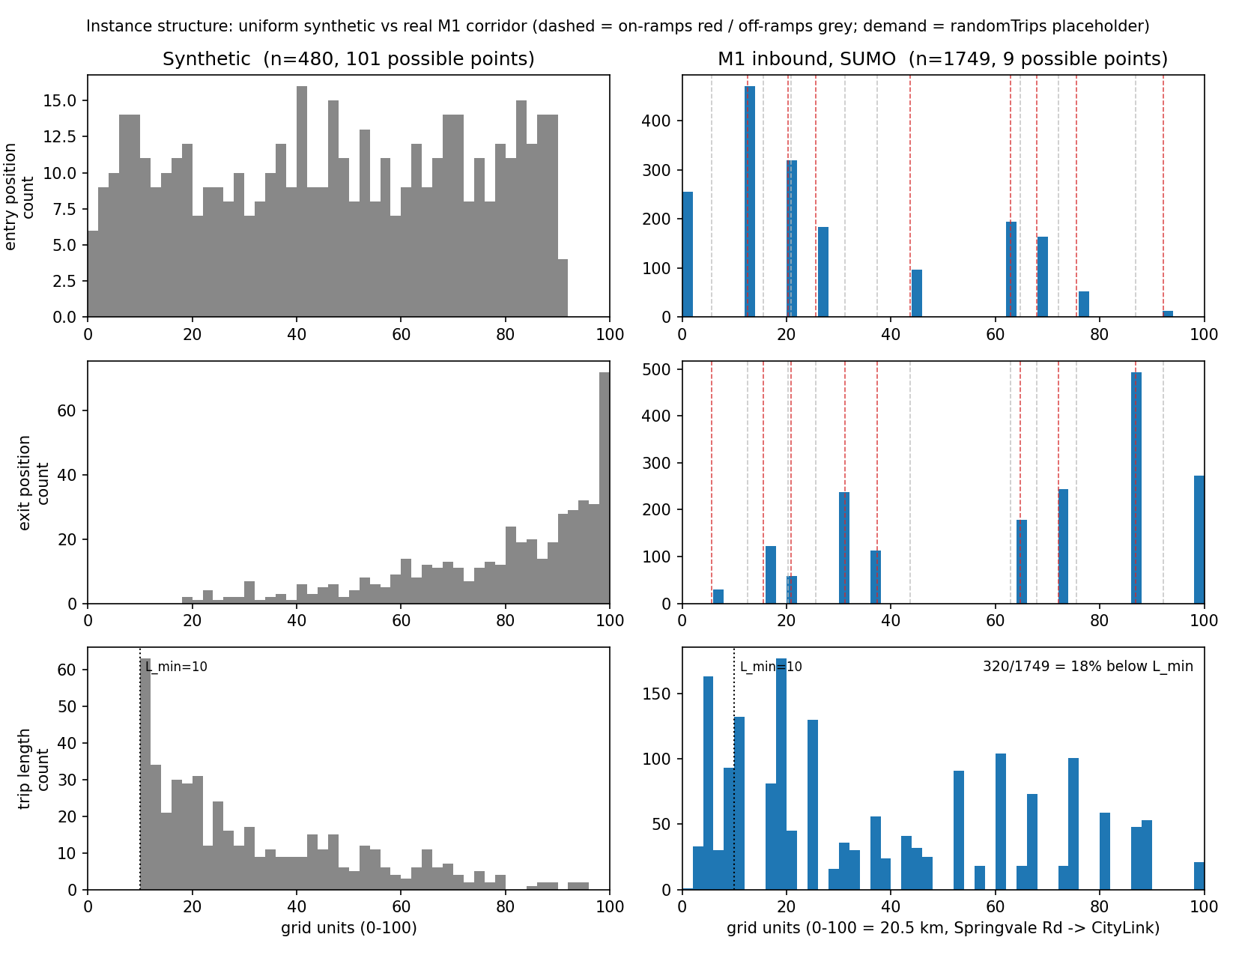
Figure 2. Entry position, exit position and trip length: uniform synthetic data (left) vs the M1 corridor (right). Dashed lines are ramp positions.

3.2 The constant-speed assumption breaks on long trips
The model assumes each vehicle keeps one speed. Fitting the best constant speed to each simulated trajectory and measuring the residual gives a lower bound on that error:
Trip length | Vehicles | Median max error | Share above τ = 5 s
< 4 km | 710 | 0.6 s | 0 %
4–10 km | 435 | 2.5 s | 36 %
10–15 km | 322 | 13.9 s | 95 %
> 15 km | 282 | 21.9 s | 100 %
Lane count changes (3 → 6), merges and exit slow-downs accumulate over 20 km. If τ = 5 s is read literally, the model is outside its tolerance for almost every trip longer than 10 km. This connects to Revision Plan item 10 (temporal synchronisation).

3.3 Greedy vs ILA on the M1, by AV:PV ratio
Five seeds of random AV / PV labels on placeholder demand — a first look, not a result. Mean ± standard deviation across seeds.
AV : PV | 0.2 | 0.4 | 0.6 | 0.8
ILA − greedy, time constraints OFF | 0.00 | 0.00 | 0.00 | 0.00
ILA − greedy, time constraints ON | +0.77 ± 0.33 pp | +1.40 ± 0.40 pp | +1.08 ± 0.20 pp | +0.41 ± 0.17 pp
Saving, ILA, time ON | 45.1 % | 61.1 % | 59.5 % | 54.7 %
PV distance covered | 53 % | 85 % | 96 % | 98 %

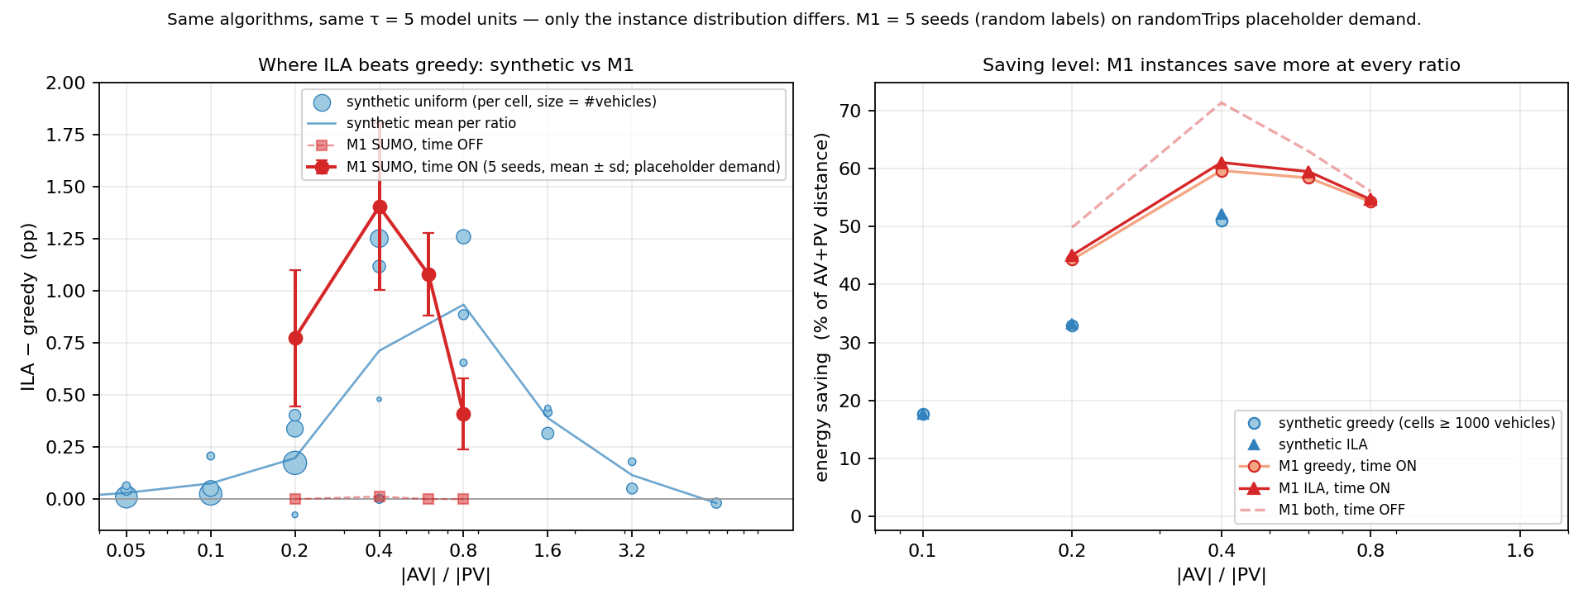
Figure 3. ILA − greedy against AV:PV ratio (left) and saving level (right): synthetic data (blue, 4–8 seeds per point) vs M1 (red, 5 seeds, mean ± sd).
- Without time constraints the two algorithms tie exactly at every ratio. ILA's advantage is temporal — the same finding as on synthetic data and in the 7 Sep report.
- With time constraints the gap is an inverted U, peaking at ratio 0.4 on the M1 (0.8 on synthetic), consistently across all five seeds. By ratio 0.6, 96 % of PV distance is already towed, so there is nothing left to compete for.
- The paper's saving metric divides by AV + PV distance, so it falls past 0.4 as AV distance (which can never be saved) grows in the denominator. PV coverage rises monotonically.

3.4 Reminder from the 7 Sep report
Against the exact optimum (21 instances up to 15 AV / 30 PV) greedy reaches 93.3 % and ILA 93.1 %. The shortfall is choice quality, not model expressiveness: restricting the model to the segments the algorithms can produce costs only 0.65 %.

4. What this means
- SUMO did not widen the ILA–greedy gap. +0.4 to +1.4 pp (5-seed means) on the M1 versus +0.2 to +1.3 pp on synthetic data. Realistic structure does not turn a 1-pp difference into a 5-pp one. Three independent checks (synthetic re-analysis, exact optimum, SUMO) now agree.
- The 7 % headroom to the optimum is seven times the ILA–greedy difference. Both heuristics under-use the multi-segment hand-off that the exact solutions exploit (more, shorter segments; 88 % of PVs served vs 75 %).
- The paper never fixes what τ = 5 s means physically. On the M1 one model time unit is about 8 s, so τ = 5 is either 5 s (saving halves: 24 %) or ≈ 42 s (50–52 %). Both readings are self-consistent; the paper has to pick one.
- Real demand data exists but covers 40 % of the corridor. DTP TIRTL detectors (15-min counts, CC BY 4.0) sit at 16 main-line sites between Springvale Rd and Warrigal Rd plus the High St ramp; nothing from Burke Rd to CityLink (toll road). All are point counts, no origin–destination information.

5. Feedback I need
- The claim. Given 1–2 above, the Revision Plan's Phase-2 decision point ("if the gap does not widen, the contribution needs rethinking") has arrived early. Options: (A) a method that closes part of the 7 % — I would test a local-search post-processor for two weeks against the 21 exact instances; (B) reposition the paper as problem + exact benchmark + realistic evaluation, with ILA as "greedy-quality, faster"; (C) 2D — but the exact-solver diagnosis says the loss is choice quality, not expressiveness, so 2D alone would not change it. My proposal: B as the floor, A as a two-week test. Do you agree with the reading and the test?
- AV:PV ratio. Your note "specialised → quite high": did you mean the ratio should be high (many AVs) or the gap should be high? My framing: ratio = (share of heavy vehicles that can tow) ÷ (share of cars opting in). What range should the sweep cover, and which metric — the paper's saving over AV + PV distance, or PV distance covered?
- AV / PV labelling in SUMO. Random fraction (current placeholder), by vehicle class (trucks / buses = AV), or something else?
- Demand. (i) keep the placeholder; (ii) partial calibration to TIRTL counts via routeSampler — 2–3 days, gives "calibrated to DTP detector counts" for the eastern 40 %, must be labelled partial; (iii) full calibration — not possible with open data. I recommend (ii) for this paper and (iii) for the 2D paper.
- Physical unit of τ. 5 real seconds or 5 model units (≈ 42 s)? Under (ii) entry times come from real-second counts, so real seconds is the natural reading. Should long trips use piecewise speeds given the 22 s drift?
- Scale. Keep 400 PV / 100 AV as the headline, or a full peak hour (≈ 1750 vehicles on the main line)?

6. Proposed next steps (pending the above)
- If (A) is approved: local-search post-processor, scored against the 21 exact instances; report at the next fortnightly update.
- If (ii) is approved: download one TIRTL month, map detectors to edges, enumerate candidate routes, routeSampler, report GEH.
- Implement the agreed labelling rule and τ convention; re-run the ratio sweep with 10+ seeds and confidence intervals.
- Extract 5-minute sub-windows of the M1 scenario (≈ 10 AV / 25 PV) so the exact solver can score both heuristics on real structure.

Code and notes: github.com/JayReeMarine/… — sumo/NOTES-sumo.md (SUMO track), NOTES.md (exact solver), README.md "Revision Work" for the commands.

